About Us  At Planning and Development Services, we take care of our community Enoch Cree Nation’s lands and resources, making sure they're used wisely and protected for future generations.  We're dedicated to preserving the environment, managing waste, and controlling pollution. We also ensure that our community is involved in making decisions about the land and resources. Additionally, we create long-term plans for land use that align with our community's needs and values.  Our aim is to promote the sustainable growth and well-being of our Nation and lands. | Get in Touch  We believe in personalized service and direct communication. If you have any further questions or would like to discuss how we can specifically help meet your needs, please feel free to reach out directly to our Senior Manager.  Sally Thomas  Senior Manager  Sally.thomas@enochnation.ca  (O) 780-470-4505 (C) 780-707-1884  Contact today for any questions  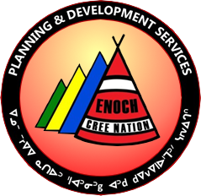  Planning and Development Services  Enoch Administration Building  PO Box 29, Enoch, AB  T7X3Y3 | Planning and Development Services
Our Team  Welcome ᑕᐋᐧᐤ tawâw  Here are our departments  Planning Department  - Develops and executes land use plans and policies for the community's long-term goals.  - Ensures land use plans are consistent with community values, interests, and needs.  - Provides guidance and support on planning and development issues.  - Christopher Morin  Planning Manager  Christopher.morin@enochnation.ca  (O)780-470-4505 (C) 780 906-3122  Lands Department  - Responsible for community lands and resources administration and management.  - Aims to ensure sustainable use and protection of resources for future generations.  - Collaborates with other departments and agencies on land use plans, land agreements, and land management practices.  - Cody Morin  Lands Coordinator  Cody.morin@enochnation.ca  (O) 780-470-4505 (C) 587-338-9424  - Brenda Cardinal  Lands Coordinator  Brenda.cardinal@enochnation.ca  (O) 780-470-4505 (C) 587-708-6284  - Bryant McDonald  Oil and Gas Compliance Coordinator  Bryant.mcdonald@enochnation.ca  (O) 780-470-4505 (C) 780-904-1663 | 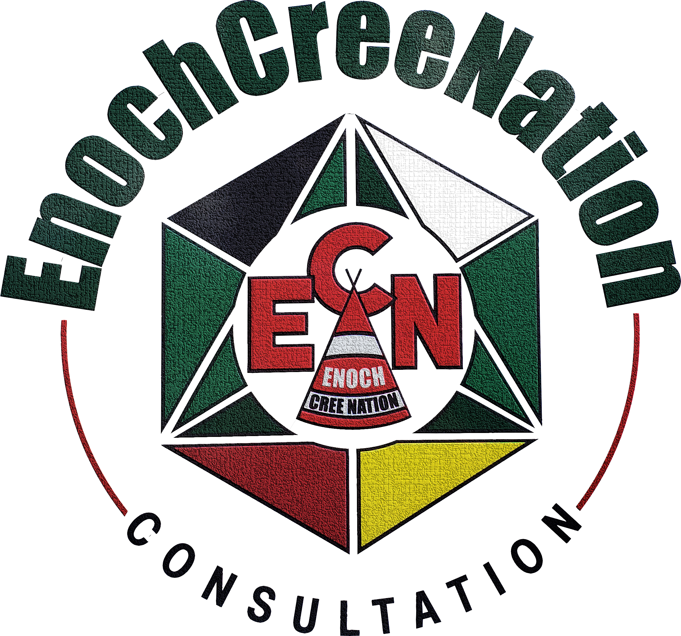  Consultation Department  - Facilitation of effective and meaningful consultation with Industry & Government  - Conducting Traditional Use Site Assessments.  - Provide recommendations to mitigate adverse impacts resulting from development and  - cumulative effects.  - Stephana Morin  Consultation Coordinator  Stephana.morin@enochnation.ca  (O) 780-470-4505 (C) 587-936-8468  - Shailley Peacock  Consultation Coordinator  Shailley.peacock@enochnation.ca  (O)780-470-4505 (C)780-819-9459 | Environment Department  - Works to protect and preserve the natural environment and resources.  - Develops and implements programs for environmental sustainability, waste management, conservation, and pollution control.  - Collaborates with other agencies to address environmental issues and concerns.  - Naomi Torres  Environment Specialist  Naomi.torres@enochnation.ca  (O) 780-470-4505  - Marissa Gutsch  Environment Coordinator  Marissa.gutsch@enochnation.ca  (O) 780-470-4505 (C) 780-240-9611  The departments of Planning and Development Services provide their unique expertise and skills to promote the continuous growth and development of our community, Enoch Cree Nation, and welcome any questions or requests for more information.  Thank You,  ᑭᓇᓈᐢᑯᒥᑎᐣ kinanâskomitin

