Mission Statement  We promote sustainable development and sound management practices as guiding stewards of our lands. We are committed to managing, protecting, and improving our lands in a manner to serve the needs of the Maskêkosak people. Management of our lands is based upon environmental responsibility within the principles of multiple uses and sustainable development of our Nation’s resources for future generations. |  |  | CONTACT US;  SALLY THOMAS, LANDS SPECIALIST  EMAIL; SALLY.THOMAS@ENOCHNATION.CA  PHONE 780-470-4505  CODY MORIN  LANDS COORDINATOR  EMAIL: CODY.MORIN@ENOCHNATION.CA  PHONE 780-470-4505  LANDS DEPARTMENT |  |  | ᐊᐢᑭᕀ askiy  Lands Department  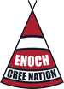

VISION STATEMENT  Enoch Cree Nation lands department will promote effective management of our lands and resources by enhancing professional development and technical expertise. We maintain the integrity of the Nation by exercising the best possible control over our land and resources. We strive to ensure the protection of the collective interests of the Nation and the individual rights of our members.  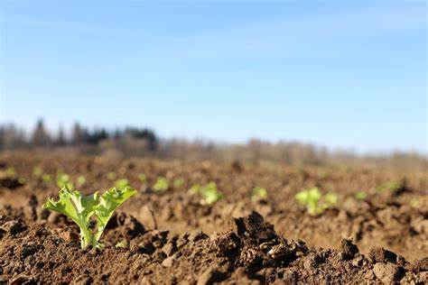 |  |  | 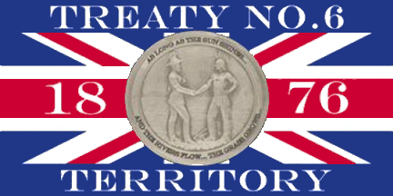  DEPARTMENT DESCRIPTION  The lands department is responsible for protecting Maskêkosak Treaty and Aboriginal Rights to preserve Maskêkosak Culture, Land Use and Traditional Ways. We ensure stewardship by engaging members in consultation and land use planning, improving relationships and understanding the needs of our stakeholders. Building and maintaining relationships with the Crown, proponents, and other parties on resource management and decision-making matters within Maskêkosak. Ensuring that Maskêkosak knowledge is respected and considered in land and resource management; economic and business development. We provide numerous services and supports to assist the needs our members and proponents. |  |  | SERVICES WE PROVIDE;  - Agricultural leases and permits  - Utility permits  - Oil and gas agreements  - Land allotments for housing  - Land referendums and Designations  - Matrimonial Real Property  - Monitoring and compliance of all land agreements within the Nation  - Provide services for certificate of possession and certificate of occupation holders including land transfers, land searches, parcel abstracts and land payments.  - Survey request and approvals  - Additions to Reserve  THE GREAT SPIRIT IS IN ALL THINGS:  He’s in the air we breathe. The great spirit is our father but the earth is our mother. She nourishes us; that which we put into the ground. She returns to us.

